**HUGHENDEN SHOW & FIELD DAYS TRADE STALLS**

To whom it may concern,

2023 will mark the 140th anniversary of the Hughenden Show & the Chamber of Commerce is once again partnering with the Show Society to implement trade stalls as part of the event. Due to the success of the event in 2022, the trade stall element is set to expand into a “Field Days” element, which will bring excellent cost-effective exposure opportunities for your business in a region set to experience substantial growth in the coming years with multiple large-scale projects in the works.

The trade stall element (this year will be called a Field Days) is set to build upon the success from 2022 by inviting “out of town” businesses into the fold. Utilizing the long-standing relationships local businesses have with their suppliers, we are pushing hard to grow this category with an achievable target of 50 stall holders in 2023.

The Show Society are investing heavily in the Show for 2023, with the implementation of the following attractions that are guaranteed to attract excellent attendance from not only the locals, but other people travelling from neighbouring shires:

* Large number of entertainment exhibits & rides including Pig Races, Batman inflatable playground, Jumping castle, Motorised mini Jeeps, side shows including clown game, chair-o-plane merry-go-round, mechanical surfboard, animal farm & MORE!
* Fireworks display
* Bar auction on the Saturday night
* Horse & Cattle sections showcasing some of best the region has to offer
* Pavilion displays showcasing the traditional side of the Show such as local arts, crafts, produce & more!

To assist in getting the 2023 Show & Field days established we are offering trade stall locations FREE OF CHARGE this year. This provides a sensational, cost-effective exposure opportunity for your business in a region that has supported your brand for many years.

If you would like to take advantage of this opportunity & support the event, please complete the form on the next page and return it ASAP as spots are limited. Please ensure you also note any additional requirements you may need (Eg Power) so we can facilitate as much as possible.

We appreciate your consideration. If you have any other questions regarding the event please don’t hesitate to contact the Hughenden Chamber of Commerce directly on the below details.

Kind regards,

**Peter Fornasier- President**

Ph: 0439 864 774

Email: hcc.secretary@outlook.com.au

**HUGHENDEN SHOW & FIELD DAYS ATTENDANCE FORM**

Field Days Dates: Friday 2nd & Saturday 3rd June 2023

Setup avail: Thursday afternoon from 3pm or Friday morning early.

** Please email completed form to [hcc.secretary@outlook.com.au](mailto:hcc.secretary@outlook.com.au) **

Business name:

Contact name:

Contact number:

Requirements:

Power: (YES/NO)

Site area required: [Eg: 6x3m]

Other requirements:

**FIELD DAYS “VENDOR PASSPORT” COMPETITION**

Please note: HCC will be facilitating a “vendor passport” competition again this year which encourages visitors to visit each stall holder and get a “stamp” on their provided passport. This assists in ensuring that everyone visits all stalls at the event, maximising your exposure to the people attending. At the end of the event, all completed passports go in the draw to win a wheelbarrow full of prizes donated by stall holders. We would appreciate it if your business could facilitate something to go towards this prize where possible.

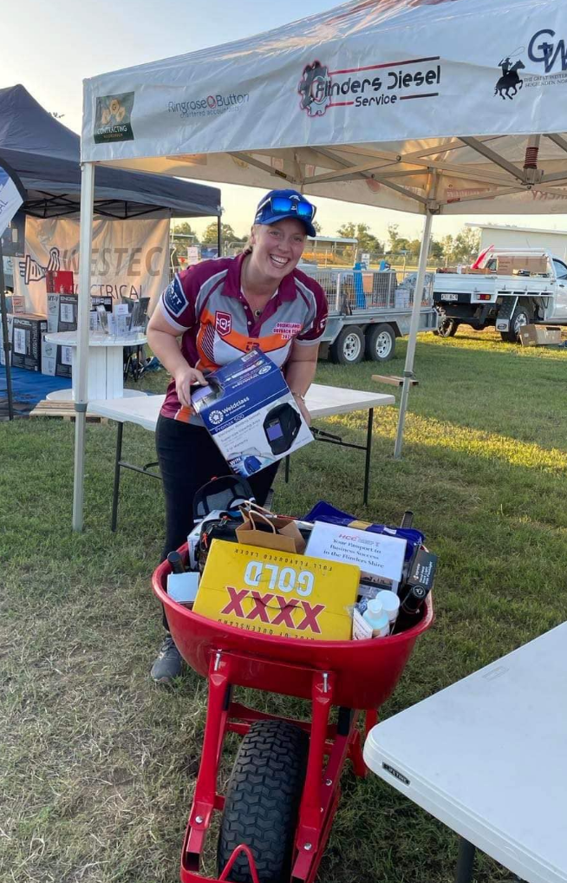 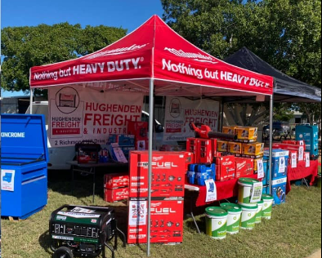 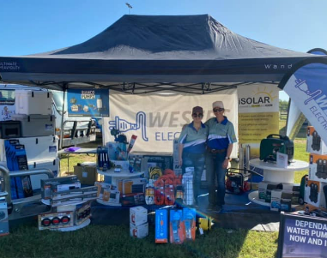 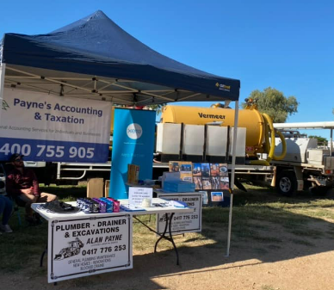

OTHER INFORMATION:

Accommodation available in Hughenden:

* **Royal Hotel Hughenden**  
  21/23 Moran St, Hughenden  
  (07) 4741 1183  
  [www.hughendenhotelmotel.com.au](http://www.hughendenhotelmotel.com.au)
* **Great Western Hotel Hughenden**  
  14 Brodie St, Hughenden  
  Ph: (07) 4741 1454
* **Hughenden Guest House**  
  2 Flynn St, Hughenden  
  0417094501  
  <https://hughendenchamber.com.au/place/hughenden-guest-house/>
* **Hughenden Allen Terry Caravan Park (Camp sites & cabins available)**2 Resolution St, Hughenden QLD 4821  
  Ph: (07) 4741 1190  
  [www.hughendenvanpark.com.au](http://www.hughendenvanpark.com.au)
* **Hughenden Free RV Park**  
  Free location with no power access for Caravans and camping setup  
  Next to the Showgrounds- limited spots available.
* **Rest Easi Motel**  
  11 Richmond Hill Dr, Hughenden  
  (07) 4741 1633

**Sponsorship opportunities:**

Refer attached Sponsorship Package document.

Hughenden Show & Field Days location:

Hughenden Showgrounds- Stansfield St, Hughenden QLD 4821

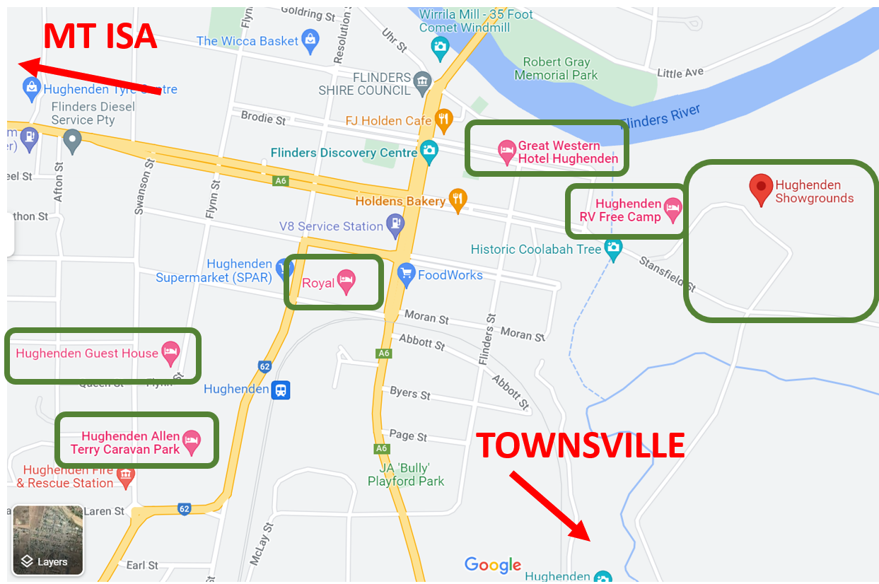

Business directory:

<https://hughendenchamber.com.au/membership/member-directory/>

<https://www.visithughenden.com.au/>

**2023 Hughenden Show & Field Days Major Sponsor:**

