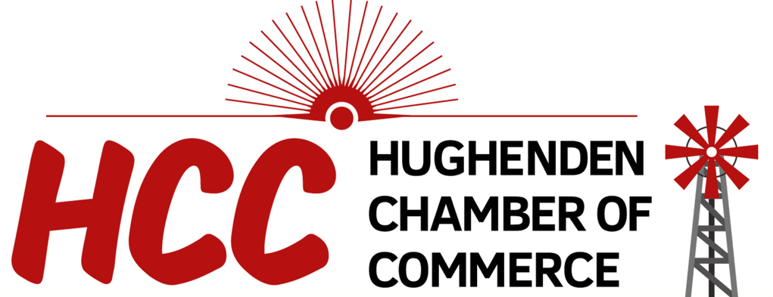

SHOP LOCAL CAMPAIGN

TERMS AND CONDITIONS OF ENTRY
- Information on how to enter the Competition forms part of these terms and conditions of entry. Participation in this Competition is deemed acceptance of these terms and conditions of entry.
- This Competition is being run by the Hughenden Chamber of Commerce ABN 17087838224.
- The Competition commences at 6am on 1st November 2023 and concludes at 5pm 30th November 2023 (‘Promotional Period’).
- The promoter of this Competition is The Hughenden Chamber of Commerce (PO Box 198 Hughenden QLD 4821)
- Committee executives from the Chamber of Commerce are not eligible to enter this competition.
- Number of entries: multiple entries are permitted by customers during the duration of the promotion. One entry per receipt.
- Entrants must be permanent residents of Queensland and reside in the Flinders Shire Council Local Government Area to be eligible to enter.
- If there is any inconsistency between these Terms and Conditions and anything else that refers to this competition, these Terms and Conditions prevail.

COMPETITION
- People may enter the Competition by shopping at any current (paid) Chamber of Commerce members’ business in the Flinders Shire.
- To be eligible for the Competition, purchases must be over the value of $20 including GST.
- To enter customers will need to write their name, phone number on the receipt. Receipts must be deposited into designated boxes provided by the business the money was spent at.
- The prize winner will be drawn at random on the 1st December 2023 as part of the Community Christmas Party from the collection of receipts.
- There are 2 prize draws with the prize for each draw being a $500 voucher to any current member business or businesses of the Hughenden Chamber of Commerce as at 12 pm on Friday 1st December 2023.
- The Promoter reserves the right to draw additional reserve entries and record them in order in case an invalid entry or ineligible entrant is drawn. The winner need not be present at the draw.
- The winner of the Prize will be notified by phone or email within two business days of being drawn. The name of the winner will also be published on the Chamber of Commerce Facebook page within two business days of being finalised.
- Prize to be collected from the Hughenden Chamber of Commerce within 2 weeks from the date of the winner being notified. Failure to collect the Prize within this time will result in it being forfeited and the Promoter may draw another winner for the Prize, subject to any approval or directions of a relevant regulatory authority.
- Voucher or any unused portion of a voucher is not exchangeable or transferable and cannot be redeemed for cash. Voucher can be used for multiple purchases; any unused value of the card will become void.
- Voucher will expire after a period of 12 months from the date of issue.
- The Promoter reserves the right to verify the validity of entries, prize claims and entrants (including an entrant’s identity, age and place of residence) and to disqualify any entrant who submits an entry that is not in accordance with these terms and conditions or who tampers with the entry process. An entry that is incomplete, indecipherable, illegible or non-compliant with these terms and conditions is invalid and will not be accepted or considered. Failure by the Promoter to enforce any of its rights at any stage does not constitute a waiver of those rights.
- If this Competition is interfered with in any way or is not capable of being conducted as reasonably anticipated due to any reason beyond the reasonable control of the Promoter, the Promoter reserves the right, in its sole discretion, to modify, suspend, terminate or cancel the Competition to the full extent permitted by law and subject to any approval or directions from a regulatory authority.
- The Promoter's decision is final and no other correspondence will be entered into.
- It is a condition of entry that the entrant consents to the Promoter using the entrant’s name and image in the event they are a winner of a Prize (including photograph, film and/or recording of the same) in any media for an unlimited period without remuneration for the purpose of the Competition (including any outcome), and promoting any products and services, distributed and/or supplied by the Promoters.
- By entering the Competition, an entrant releases and indemnifies the Promoter (including its executive committee) from and against all actions, liabilities, penalties, claims or demands the entrant may have against the Promoter or that the Promoter may incur for any loss or damage which is or may be suffered or sustained as a direct or indirect result of an entrant entering or participating in the Competition or winning or failing to win a prize, or using or permitting any other person to use the prize, except for any liability which cannot be excluded by law or which would cause any part of this clause to be void or unenforceable.

PRIVACY STATEMENT
The promoter will be collecting entrants’ personal information, such as name and phone number in order to contact the winners of the competition and to advise the public of the winners. Personal details will only be used for purpose of the Shop Local Competition. Personal information will not be used other than for the purpose of Shop Local Competition without consent, unless required by law. All information provided will be handled in accordance with the Information Privacy Act 2009.

PROMOTER’S LIMITATION OF LIABILITY
- The Promoter is not responsible for the loss of prizes due to incorrect or imprecise delivery details provided by a winner. The Promoter also takes no responsibility for prizes lost or stolen after they have been released for delivery via postage or courier.
- The Promoter makes no representations or warranties as to the quality, suitability or merchantability of any of the goods and/or services offered as prizes.
- To the extent permitted by law, the Promoter is not liable for any loss suffered or sustained by any person and including, but not limited to consequential (including economic) loss by reason of any act or omission, deliberate or negligent, by the Promoter, or its servants or agents, in connection with the arrangement for supply, or the supply, of any goods or services by any person to the prize winners and, where applicable, to any persons accompanying the winners.
- The Promoter will not be responsible for any incorrect, inaccurate or incomplete information communicated in the course of, or in connection with, this promotion if the deficiency is occasioned by any cause outside the reasonable control of the Promoter including but without limitation technical malfunctions or failures.

PRIVACY AND COLLECTION NOTICE
All entries become and remain the property of the Promoter and its related parties, subject to the limits contained in the Privacy Statement and as set out in these terms and conditions.

